High School Uniforms
Available at: Sam Harris Uniforms – 1025 N Sheridan Peoria IL 61606

Please note:

*Incoming freshmen will be able to wear their uniforms from middle school until they outgrow them and all high school students will be able to wear their old uniforms until they are unwearable or outgrown as well.

**Long sleeved uniform tops and ties will be available for fall. Please watch for announcements

***There will be two other outerwear choices soon.

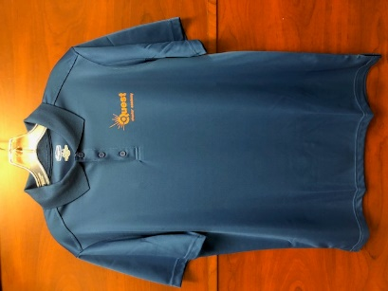

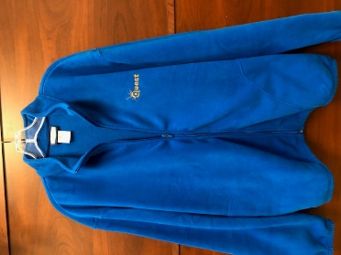

Short Sleeved Moisture Wicking Polo
100% Polyester

Youth Sizes $13.95
Girls Sizes $15.00
Adult Sizes $16.95
Junior Cut Sizes $17.00

Long Sleeved Fleece Jacket Full Zip
100% Polyester

Adult Sizes $27.00

