2017-2018 HIGH SCHOOL STAFF DIRECTORY

ADMINISTRATION & SUPPORT:
DR. NICOLE COURI WOOD MS. DEBORAH LAHOOD
Executive Director Business Manager
309.402.0030 ext. 206 309.402.0030 ext. 311
wood@questpeoria.org lahood@questpeoria.org

MRS. CINDY ARDIS JENKINS MRS. BARB CLOSEN
Director of Development & Director of Curriculum &
Communications Instruction
309.402.0030 ext. 106 309.402.0030 ext. 213
ardisjenkins@questpeoria.org closen@questpeoria.org

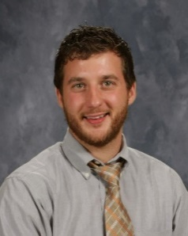
MS. ROBYN MCCRACKEN MR. ADAM HERRMANN
Principal Assistant Principal
309.402.0030 ext. 303 309.402.0030 ext. 302
mccracken@questpeoria.org herrmann@questpeoria.org

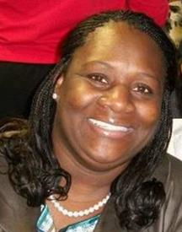
MRS. APRIL TROYER MRS. KERTRINA DICKERSON
Counselor & Student Services Family & Community Liaison
Manager 309.402.0030
309.402.0030 ext. 307 dickerson@questpeoria.org
troyer@questpeoria.org

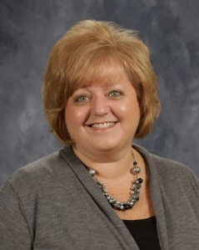
MR. ADELL HAWKS MRS. SUSAN STENGER
Discipline Officer Administrative Assistant
309.402.0030 ext. 215 309.402.0030 ext. 300
hawks@questpeoria.org stenger@questpeoria.org

MS. FELICHA BROWN MR. GENE GRIDER
Career Specialist Maintenance Director
309.402.0030 ext. 103 309.402.0030 ext.
brown@questpeoria.org grider@questpeoria.org

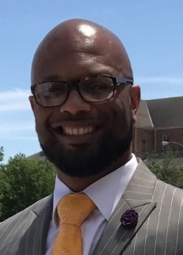
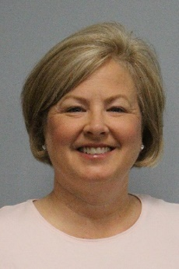
MS. CHERYL KAISER MR. ELMER DICKERSON
Assistant Business Manager Athletic Director
309.402.0030 ext. 304 309.402.0030
kaiser@questpeoria.org ad@questpeoria.org

TEACHERS
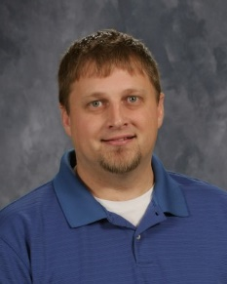
MR. JASON BEINTUM MR. RICHARD BENSON
Art Biology, Anatomy & Physiology
309.402.0030 ext. 106 309.402.0030 ext. 113
beintum@questpeoria.org benson@questpeoria.org

MISS KIMBERLY BIGELOW MR. TRAVIS CAZEL
Foreign Language Lab English IV, Reading/Writing
309.402.0030 ext. 109 Workshop
bigelow@questpeoria.org 309.402.0030 ext. 107
cazel@questpeoria.org

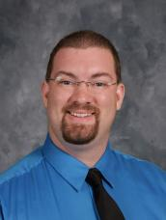
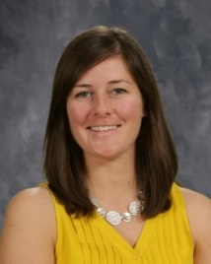
MRS. COLLEEN DONLAN MR. ADAM DRAKE
Government, US History, Music
Psychology 309.402.0030 ext. 103
309.402.0030 ext. 211 drake@questpeoria.org
donlan@questpeoria.org

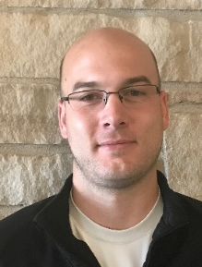
MR. TIM FINNEY MR. JUSTIN GOLDENSOPH
Algebra II, Pre-Calculus Physical Education
309.402.0030 ext. 219 309.402.0030
finney@questpeoria.org goldensoph@questpeoria.org

MISS RACHEL HECKMAN MISS JULIANNE LEFEBVRE
English III, Senior Seminar Geometry, Business Math
309.402.0030 ext. 217 309.402.0030 ext. 207
heckman@questpeoria.org lefebvre@questpeoria.org

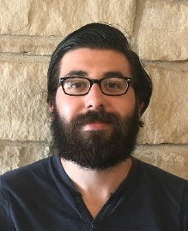
MR. MARC LOWE MR. JOSEPH MARTINELLI
Hall Monitor Freshman Success, Economics,
309.402.0030 ext. 215 Sociology
lowe@questpeoria.org 309.402.0030 ext. 111
martinelli@questpeoria.org

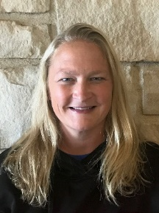
MISS MEAGHAN SLEVIN MRS. PAM SOUTER
English/Writing I, Poetry English II, Creative Writing
309.402.0030 ext. 210 309.402.0030 ext. 108
slevin@questpeoria.org souter@questpeoria.org

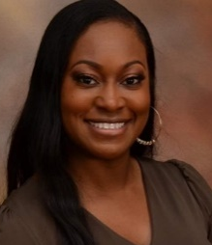
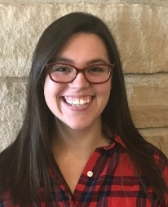
MRS. FREYDA SPRATTLING MRS. SOPHIE TOWNSEND
Special Services Chemistry, Earth Science,
309.402.0030 ext. 212 Physics
sprattling@questpeoria.org 309.402.0030 ext. 216
townsend@questpeoria.org

MISS ELIZABETH UNDERHILL MR. MIKE UNDERHILL
Technology Project Lead the Way (IED),
309.402.0030, ext. 218 U.S. History,
eunderhill@questpeoria.org Problem/Design/Solve
309.402.0030 ext. 209
underhill@questpeoria.org

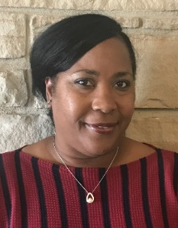
MRS. JENNIFER WELCH-FARRELL
Special Services
309.402.0030 ext. 212
welchfarrell@questpeoria.org

